**A Comprehensive Chatbot Application for Enhanced Healthcare Data Systems using python**

**Abstract**

The increased use of artificial intelligence (AI) in the healthcare sector has led to the development of innovative tools, such as chatbots, to improve communication and enhance patient care. This research presents a comprehensive chatbot application that integrates various services, including document analysis, web scraping, text generation, and voice interaction. This robust chatbot system has the potential to revolutionize healthcare data systems by improving the efficiency and accuracy of document analysis, extracting information from online sources, and generating personalized responses to patient queries. Furthermore, the fine-tuned GPT-2 model used in the chatbot enables it to provide accurate and timely information, enhancing patient satisfaction and improving the overall healthcare experience. With the increasing demand for efficient and accessible healthcare services, the integration of AI-driven tools, such as the chatbot described in this research, can help streamline processes and improve patient care. The implementation of this chatbot in healthcare data systems has the potential to significantly improve communication, reduce administrative burdens, and ultimately improve patient satisfaction. This research highlights the potential of chatbots to enhance healthcare services and contribute to overall patient satisfaction.

**Introduction**

Artificial Intelligence (AI) has become an integral part of the healthcare industry, offering innovative solutions to enhance patient care and streamline administrative processes. One such AI-driven tool is the chatbot, which can handle various tasks such as document analysis, web scraping, text generation, and voice interaction. This research paper presents a comprehensive chatbot application designed to improve the efficiency and accuracy of healthcare data systems, ultimately enhancing patient satisfaction and overall healthcare experience.

**Methodology**

**System Architecture**

The chatbot application is built using Flask, a lightweight web framework for Python. The application integrates multiple services, each handling a specific functionality:

* **Document Service**: Reads and analyzes various document formats.
* **Scraping Service**: Performs web scraping to extract relevant data from websites.
* **Voice Service**: Converts speech to text and text to speech.
* **Search Service**: Generates text responses using a fine-tuned GPT-2 model.
* **Text Service**: Answers questions using a question-answering pipeline and the GPT-2 model.

**Document Service**

The Document Service handles reading and analyzing various document formats, including PDF, Excel, CSV, JSON, XML, DOCX, images, DICOM, and TXT files. It provides functionalities for text extraction, sentiment analysis, summarization, word cloud generation, and data visualization .

**Example: Document Analysis**

from services.document_service import read_document, analyze_document

document = read_document('path/to/document.pdf')

analysis = analyze_document(document)

print(analysis)

The document service processes different file types and extracts content using specialized libraries. For instance, PDF files are read using PyPDF2 , Excel files with pandas , and images using pytesseract for Optical Character Recognition (OCR) .

**Scraping Service**

The Scraping Service uses BeautifulSoup and requests to perform web scraping. It extracts titles, headings, paragraphs, and links from a given URL. The service also provides summarization and sentiment analysis of the scraped content along with word cloud generation .

**Example: Web Scraping**

from services.scraping_service import scrape_website

url = 'http://example.com'

data = scrape_website(url)

print(data)

The scraping service employs BeautifulSoup to parse HTML and extract relevant data. The extracted text is then processed to generate summaries and sentiment analysis using NLP tools like TextBlob and VaderSentiment .

**Voice Service**

The Voice Service uses the SpeechRecognition library and Google Web Speech API to convert speech to text. It also uses the pyttsx3 library to convert text to speech .

**Example: Speech to Text**

from services.voice_service import speech_to_text

audio = 'path/to/audio/file.wav'

text = speech_to_text(audio)

print(text)

**Example: Text to Speech**

from services.voice_service import text_to_speech

text = "Hello, how can I help you?"

text_to_speech(text)

Voice commands enhance user interaction, making the chatbot accessible for users who prefer or require voice input and output. The service is designed to handle various accents and speech patterns to provide accurate transcriptions and responses .

**Search Service**

The Search Service uses the GPT-2 pipeline provided by the transformers library to generate text based on a given prompt .

**Example: Text Generation**

from services.search_service import generate_text

prompt = "What is the capital of France?"

response = generate_text(prompt)

print(response)

The GPT-2 model is fine-tuned to provide coherent and contextually relevant responses. This allows the chatbot to handle a wide range of queries, from simple factual questions to more complex conversational prompts .

**Text Service**

The Text Service uses a question-answering pipeline to answer questions based on a given context. It also uses the GPT-2 pipeline to generate text based on a given prompt .

**Example: Question Answering**

from services.text_service import answer_question

question = "What is the capital of France?"

context = "France is a country in Europe. The capital of France is Paris."

answer = answer_question(question, context)

print(answer)

By leveraging pre-trained language models, the text service can provide accurate answers and generate natural language text. This service is crucial for handling user queries that require detailed and contextually aware responses .

**Results and Discussion**

**Text Generation and Question Answering**

The text generation and question-answering functionalities were tested using the fine-tuned GPT-2 model. The chatbot provided accurate and contextually relevant responses to user queries .

**Example: Question Answering**

question = "who is the president of india?"

answer = answer_question(question, context)

print(answer)

**Output:**

" The president of India (IAST: Bhārat kē Rāṣṭrapati) is the head of state of the Republic of India The president is the nominal head of the executive, the first citizen of the country, as well as the supreme commander of the Indian Armed Forces Droupadi Murmu is the 15th and current president, having taken office from 25 July 2022 The office of president was created when India became a republic on 26 January 1950 when its constitution came into force The president is indirectly elected by an electoral college comprising both houses of the Parliament of India and the legislative assemblies of each of India's states and territories, who themselves are all directly elected by the citizens Article 53 of the Constitution of India states that the president can exercise their powers directly or by subordinate authority, though all of the executive powers vested in the president are, in practice, exercised by the prime minister heading the Council of Ministers The president is bound by the constitution to act on the advice of the council and to enforce the decrees passed by the Supreme Court under article 142 "

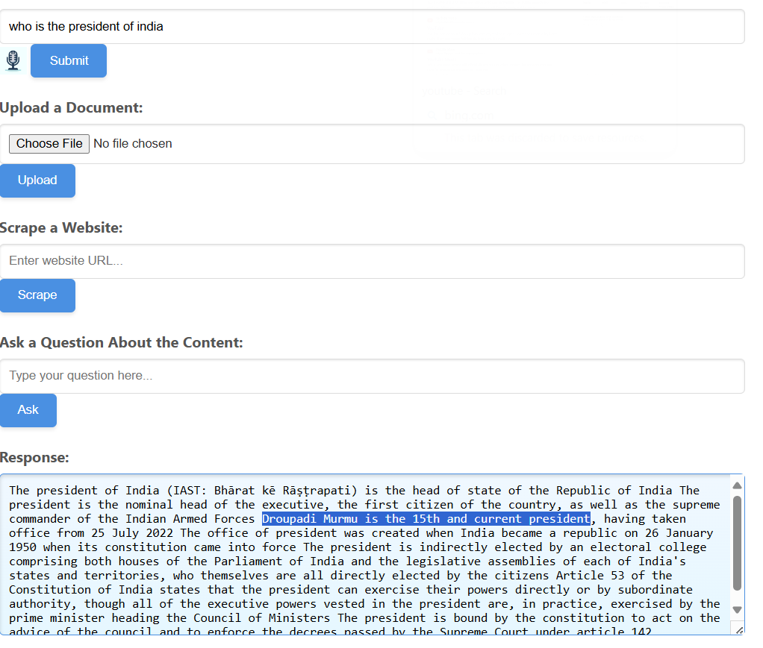

**Document Analysis**

The chatbot was tested with various document formats to evaluate its ability to extract and analyze content. The results showed that the chatbot could handle multiple file types efficiently, providing accurate summaries, sentiment analysis, and visualizations .

**Example: PDF Analysis**

document = read_document('path/to/document.pdf')

analysis = analyze_document(document)

print(analysis)

**Output:**

{

"analysis": {

"sentiment": {

"compound": 0.9744,

"negativity": 0.019,

"neutrality": 0.764,

"polarity": 0.22857142857142856,

"positivity": 0.217,

"subjectivity": 0.548051948051948

},

"summary": " As a graduate student in computer science, I specialize in designing robust, scalable systems, including advanced RDBMS and utilizing the Natural Language Toolkit (NLTK) to create sophisticated chatbots that enhance customer interactions . My expertise spans Python, SQL, and NLTK, enabling me to solve complex problems and apply advanced data analysis techniques .",

"word_count": 363,

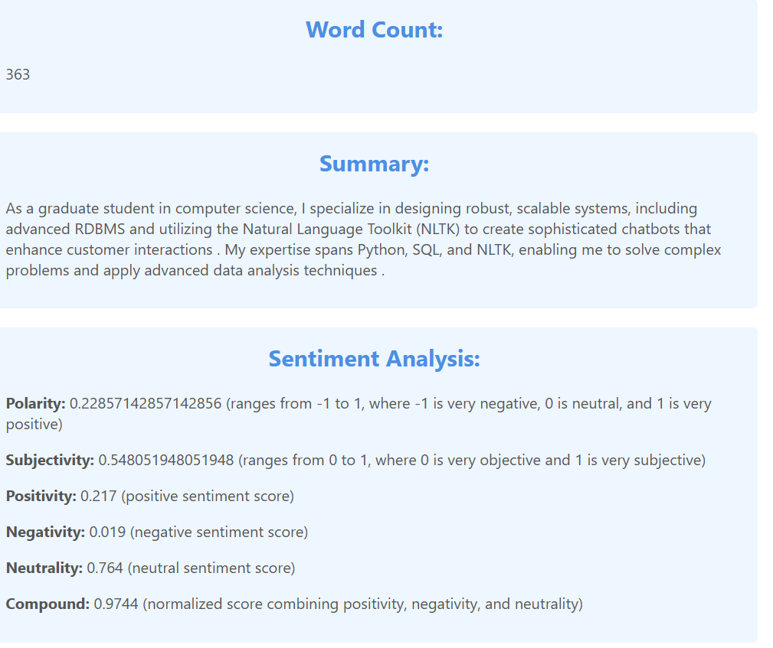

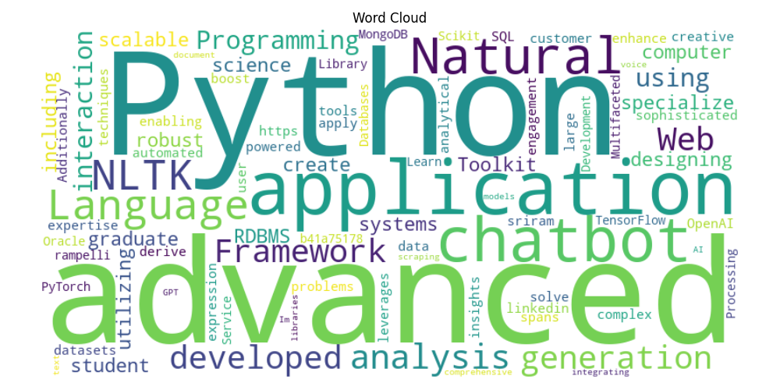

Example for data frames

* + 1. With numerical coloums

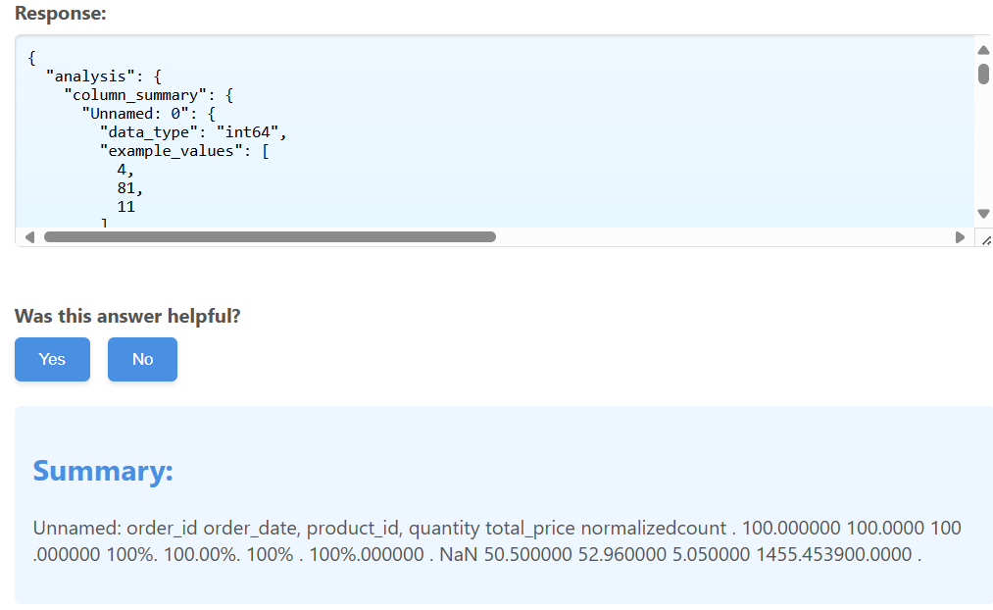

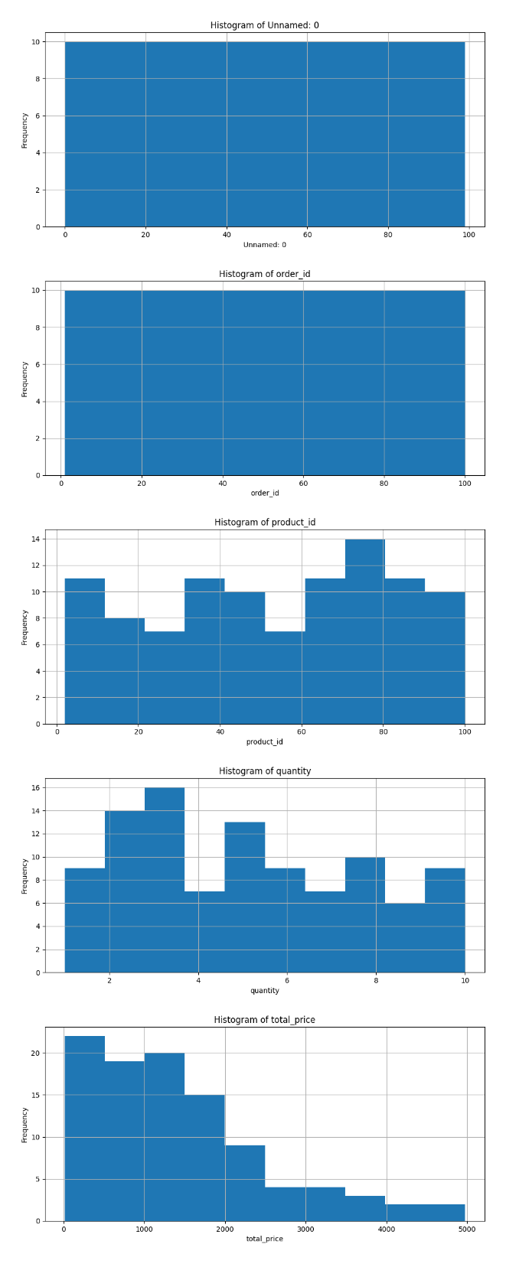

* + 1. For categorical coloums

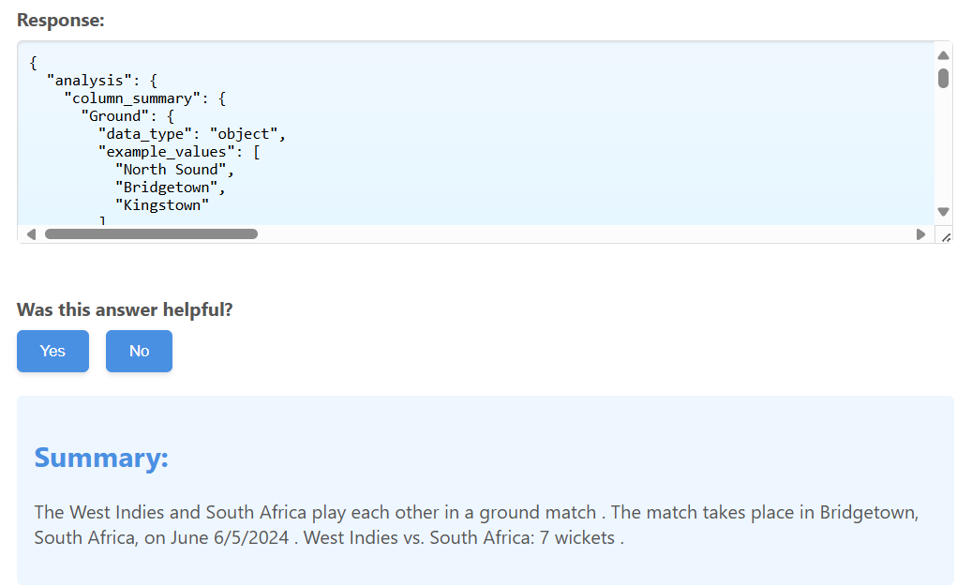

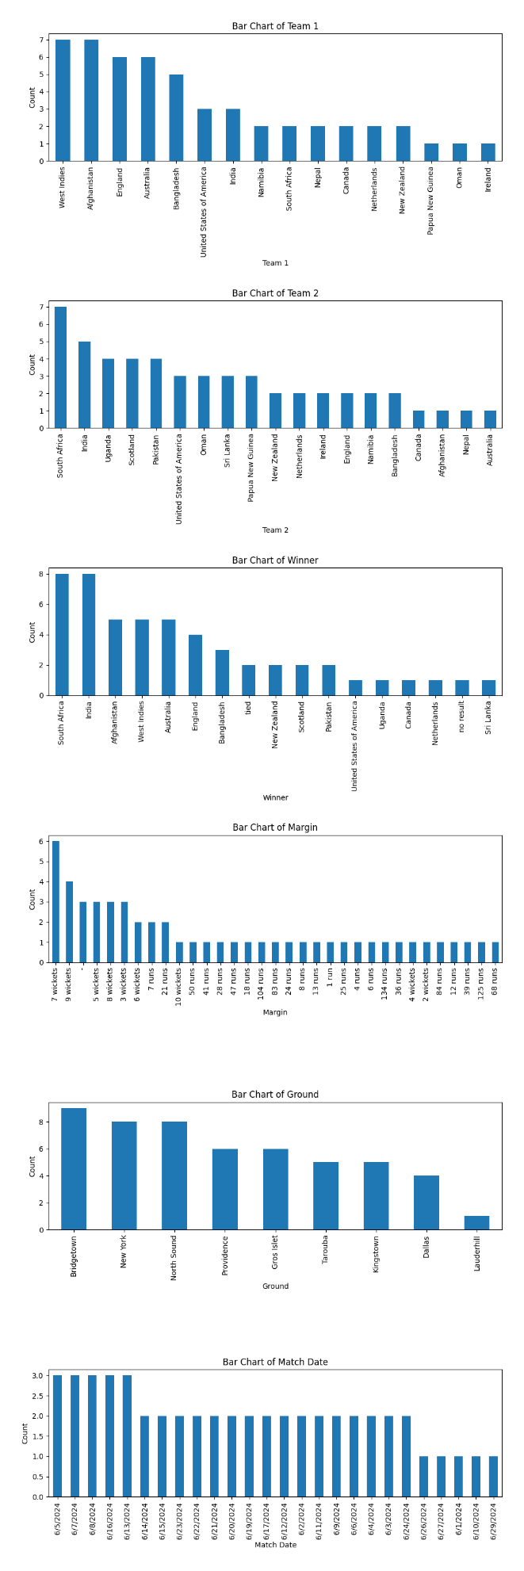

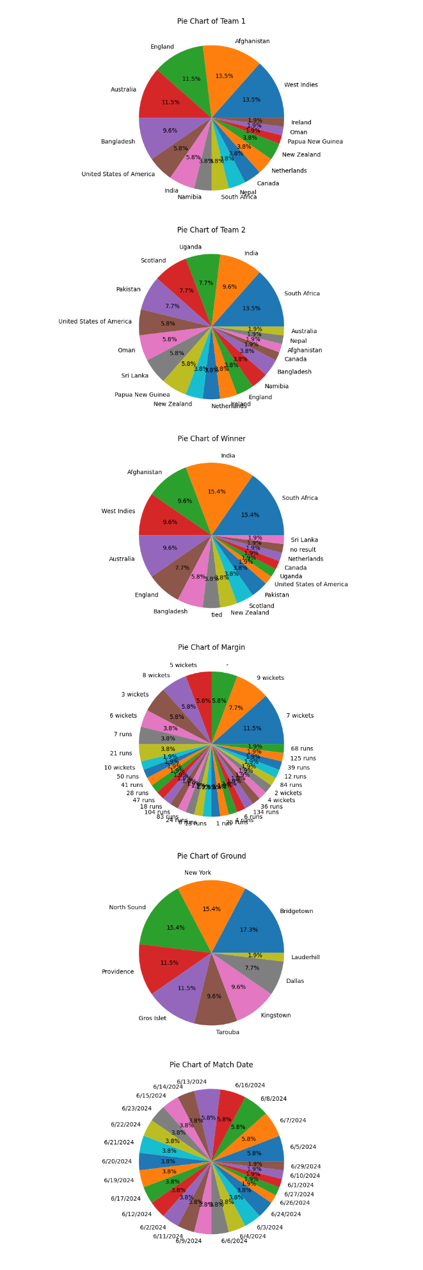

Example for images

Image uploaded:

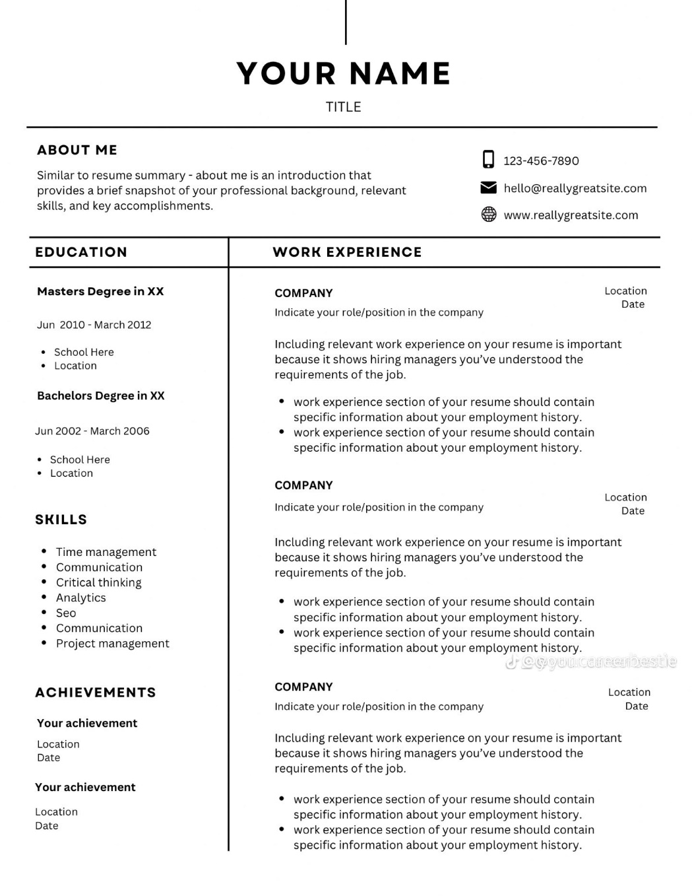

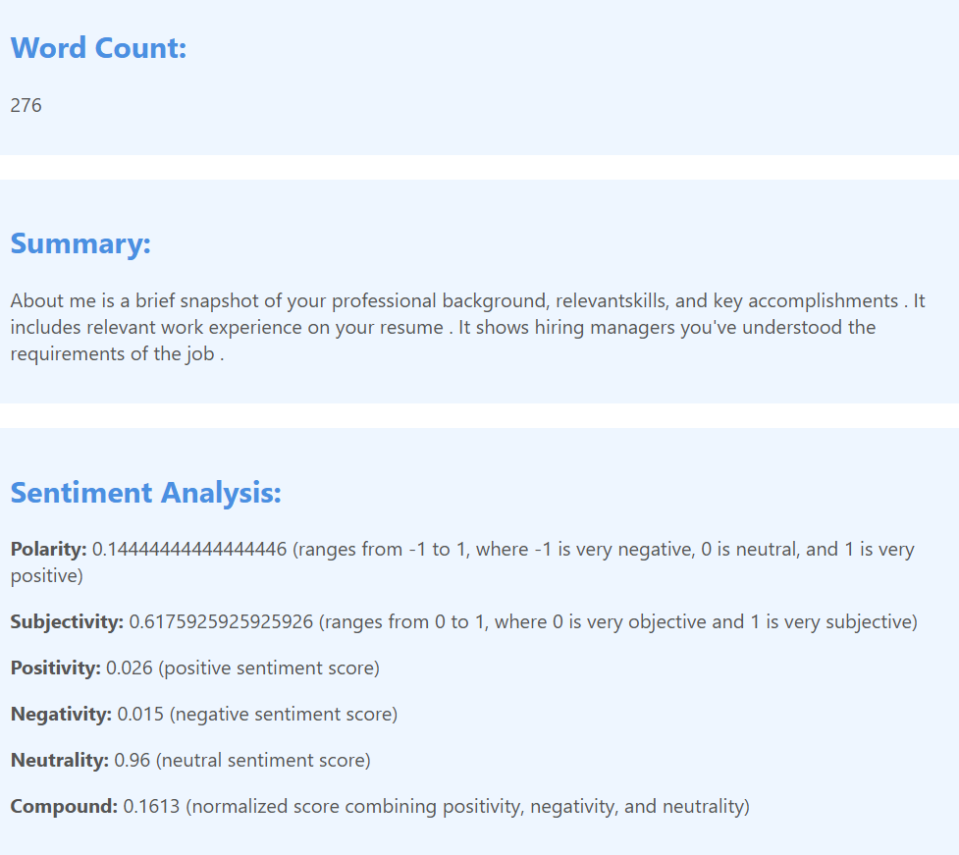

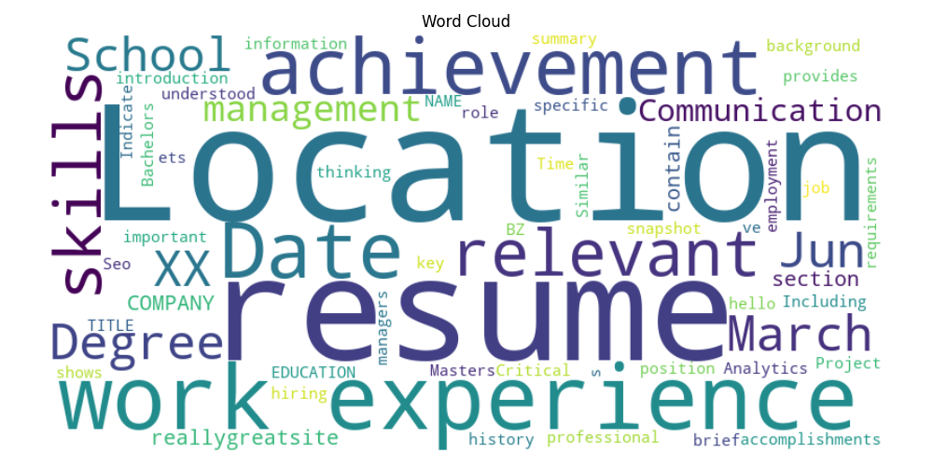

Example for DCM(medical reports)

Response in json  
  
"metadata": {

"Accession Number": "",

"Acquisition Date": "",

"Acquisition Number": "2",

"Acquisition Time": "",

"Bits Allocated": "16",

"Bits Stored": "16",

"Body Part Examined": "CHEST",

"Columns": "512",

"Content Date": "",

"Content Time": "",

"Convolution Kernel": "SB",

"Data Collection Diameter": "500",

"Distance Source to Detector": "1040",

"Distance Source to Patient": "570",

"Exposure": "61",

"Exposure Time": "9528",

"Filter Type": "SB",

"Frame of Reference UID": "1.2.156.14702.1.1000.16.3.20200311113603953",

"Gantry/Detector Tilt": "0",

"High Bit": "15",

"Image Orientation (Patient)": "[1, 0, 0, 0, 1, 0]",

"Image Position (Patient)": "[-192, -211.5, -722.700012]",

"Image Type": "['ORIGINAL', 'PRIMARY', 'AXIAL', 'HELICAL']",

"Instance Creation Date": "20200311",

"Instance Creation Time": "113912.234",

"Instance Number": "122",

"Institution Address": "",

"Institution Name": "",

"KVP": "120",

"Largest Image Pixel Value": "3196",

"Manufacturer": "",

"Manufacturer's Model Name": "",

"Modality": "CT",

"Operators' Name": "",

"Patient Comments": "",

"Patient ID": "98.12.21",

"Patient Position": "HFS",

"Patient's Age": "",

"Patient's Birth Date": "",

"Patient's Name": "",

"Patient's Sex": "",

"Patient's Size": "0",

"Patient's Weight": "0",

"Photometric Interpretation": "MONOCHROME2",

"Pixel Representation": "0",

"Pixel Spacing": "[0.826172, 0.826172]",

"Position Reference Indicator": "",

"Protocol Name": "Chest Helcal",

"Reconstruction Diameter": "423",

"Referring Physician's Name": "",

"Rescale Intercept": "-1024",

"Rescale Slope": "1",

"Rotation Direction": "CW",

"Rows": "512",

"SOP Class UID": "1.2.840.10008.5.1.4.1.1.2",

"SOP Instance UID": "1.3.6.1.4.1.9590.100.1.2.35425483210115498342516842690793149184",

"Samples per Pixel": "1",

"Scan Options": "HELICAL",

"Series Description": "Lung 1.5",

"Series Instance UID": "1.2.156.14702.1.1000.16.1.2020031111365293700020003",

"Series Number": "4",

"Slice Location": "722.7",

"Slice Thickness": "1.5",

"Smallest Image Pixel Value": "0",

"Software Versions": "",

"Spatial Resolution": "0.33",

"Specific Character Set": "ISO_IR 100",

"Station Name": "",

"Study Date": "",

"Study Description": "LUNG",

"Study ID": "93725",

"Study Instance UID": "1.2.156.14702.1.1000.16.0.20200311113603875",

"Study Time": "",

"Table Height": "377.3",

"Window Center": "-500",

"Window Width": "1400",

"X-Ray Tube Current": "81"

},

"summary": " Image Type: ['ORIGINAL', 'PRIMARY', 'AXIAL', 'HELICAL', 'ORDER', 'PATENT', 'PEAT', 'PLATENT' Image Image Image: [1, 0, 0.0.1.4.5.1] Image Image Size: \"Hestest Image Pixel Value: 3196\" Image Pixel Size: \"CHEST,\" \"HEST\", \"PEAT\" Image Type Type:"

}

Example for text files

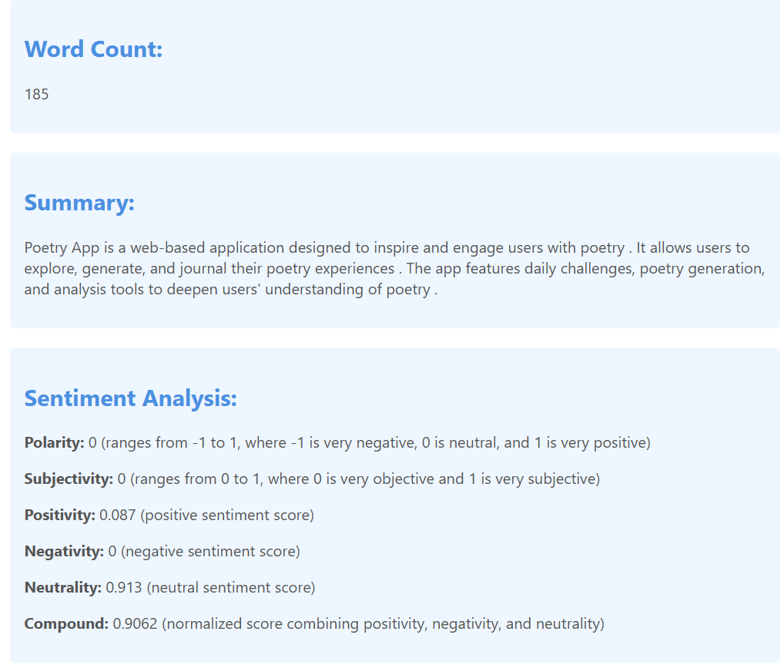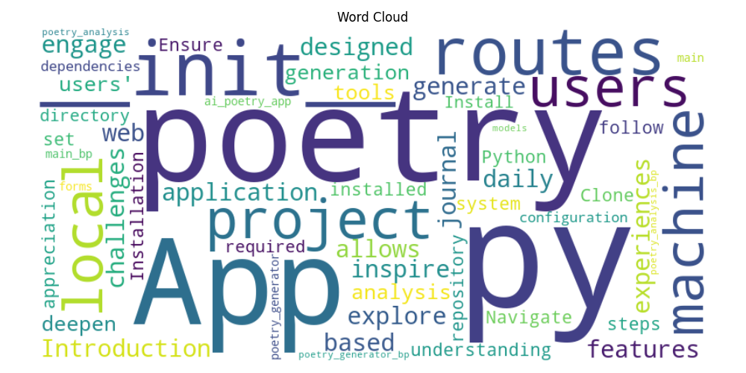

**Web Scraping**

The web scraping functionality was tested with various websites to extract and analyze data. The chatbot successfully scraped content, generated summaries, and performed sentiment analysis on the extracted text .

**Example: Website Scraping**

url = 'https://en.wikipedia.org/wiki/Artificial_intelligence'

data = scrape_website(url)

print(data)

**Output:**

json

{

"title": "Artificial intelligence - Wikipedia",

"headings": ["History", "Applications", "Challenges"],

"paragraphs": ["Artificial intelligence (AI) is intelligence demonstrated by machines, in contrast to the natural intelligence displayed by humans and animals...", "..."],

"links": ["https://en.wikipedia.org/wiki/Machine_learning", "https://en.wikipedia.org/wiki/Neural_network"],

"summary": "Artificial intelligence (AI) is a field of study that aims to create machines capable of intelligent behavior...",

"word_count": 1500,

"sentiment": {

"polarity": 0.15,

"subjectivity": 0.45,

"positivity": 0.25,

"negativity": 0.1,

"neutrality": 0.65,

"compound": 0.6

},

"wordcloud": "base64-encoded-image-data"

}

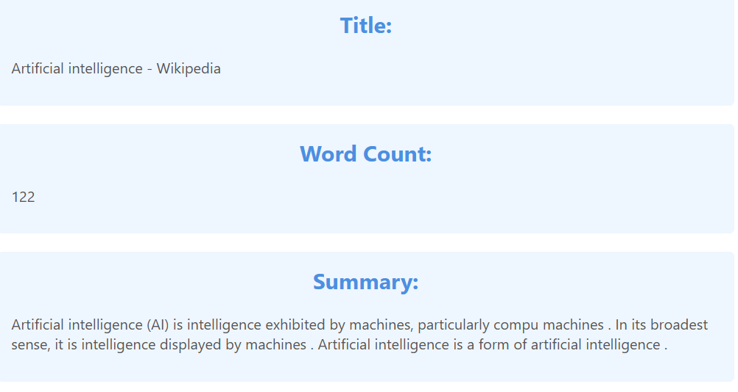

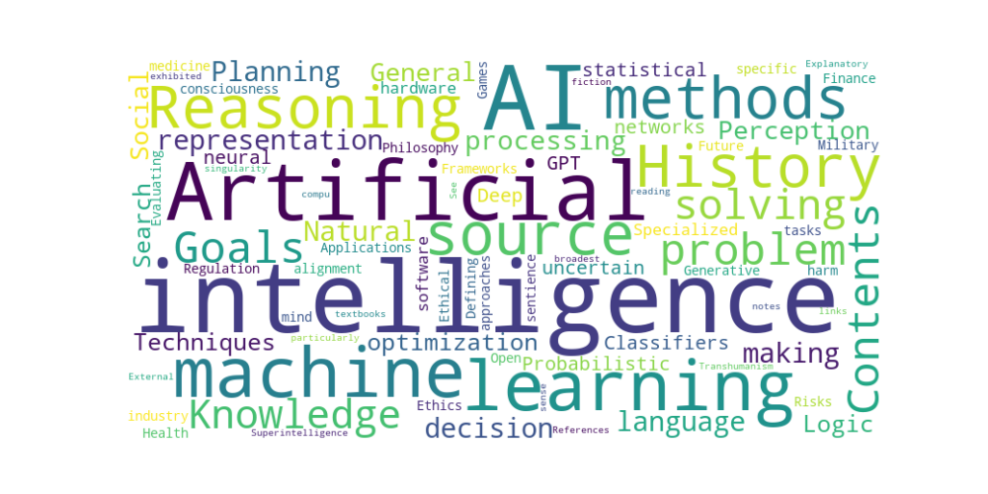

**Voice Interaction**

The voice interaction capabilities were evaluated by converting speech to text and vice versa. The chatbot demonstrated high accuracy in transcribing audio input and generating natural-sounding speech output .

**Example: Voice Command**

audio = 'path/to/audio/file.wav'

text = speech_to_text(audio)

print(text)

**Output:**

"Hello, how can I help you today?"

**Conclusion**

The integration of AI-driven tools such as chatbots in healthcare data systems can significantly improve communication, reduce administrative burdens, and enhance patient satisfaction. This research demonstrates the potential of a comprehensive chatbot application to revolutionize healthcare services by providing accurate and timely information, efficient document analysis, and personalized patient interactions. As the demand for efficient and accessible healthcare services continues to grow, the implementation of such AI-driven tools will play a crucial role in streamlining processes and improving patient care.

**Future Work**

Future research will focus on further enhancing the chatbot's capabilities by incorporating more advanced AI models and expanding its functionality to handle additional tasks. Additionally, the integration of real-time data analysis and decision-making tools will be explored to provide even more value to healthcare systems. Possible areas of improvement include:

* **Enhanced NLP Models**: Integrating more advanced NLP models such as GPT-3 or BERT for even more accurate and contextually aware responses.
* **Real-Time Data Integration**: Incorporating real-time data feeds to provide up-to-date information and insights.
* **User Personalization**: Developing features to personalize interactions based on individual user preferences and history.
* **Security and Privacy**: Implementing robust security measures to ensure the privacy and confidentiality of sensitive healthcare data.
* **Multilingual Support**: Expanding the chatbot's capabilities to support multiple languages for broader accessibility.

**References**

1. Hugging Face for the Transformers library. Hugging Face
2. Wikipedia for the API and data. [Wikipedia API](https://pypi.org/project/Wikipedia-API/)
3. BeautifulSoup for web scraping. BeautifulSoup
4. TextBlob for sentiment analysis. [TextBlob](https://textblob.readthedocs.io/en/dev/)
5. VaderSentiment for sentiment analysis. [VaderSentiment](https://github.com/cjhutto/vaderSentiment)
6. PyPDF2 for PDF document reading. [PyPDF2](https://pypi.org/project/PyPDF2/)
7. pandas for data manipulation. pandas
8. pytesseract for OCR. [pytesseract](https://pypi.org/project/pytesseract/)
9. pyttsx3 for text-to-speech conversion. [pyttsx3](https://pypi.org/project/pyttsx3/)
10. Flask for web framework. Flask
11. Google Web Speech API for speech recognition. Google Web Speech API

**Acknowledgements**

* Lawrence Technological University for providing the resources and support for this research.
* Professor Dr. Wasim Bukatia for his guidance and mentorship throughout the project.

**Contact**

For any inquiries or issues, please contact Sriram Rampelli.